DATA SCIENCE AND VISUALIZATION (24ADI204)
DEPARTMENT OF ARTIFICIAL INTELLIGENCE AND DATA SCIENCE
Team 16
WEEK 4 PROJECT REPORT
“Global Life Expectancy Paradox”
“Longevity Divide: Understanding Why Life Expectancy Differs Across Countries”
TASK: EDA DEEP DIVE – UNIVARIATE AND BIVARIATE ANALYSIS
Team Members: 25BAD052 Madhesh Kumar M
25BAD054 Manoj B
25BAD059 Mohammed Hussain N
25BAD061 Murugappan A
Faculty Guide: Ms. Rupashini
Ms. Shriaarthy E

1. Objective
The objective of Week 4 was to perform an Exploratory Data Analysis (EDA) deep dive on the cleaned dataset in the context of the Global Life Expectancy Paradox: life expectancy does not rise in step with national wealth, and countries at similar income levels can differ by more than 20 years. The analysis used univariate analysis to understand individual variables and bivariate analysis to examine how life expectancy relates to income, health, education, connectivity and region. The work was carried out using three visualizations for each analysis type. The cleaned dataset contains socio-economic, demographic and health indicators for 192 countries together with male and female life expectancy, which are combined into the average life expectancy that this analysis centres on.

2. EDA Methodology
The dataset was first loaded and inspected using shape, information, null-value counts, duplicate checks, descriptive statistics, and a list of columns. Average life expectancy was then derived as the mean of male and female life expectancy, and the female–male gap as female minus male. The analysis was divided into univariate and bivariate stages.
- Univariate Analysis: examined the distribution of average life expectancy, the number of countries per region, and the shape of six key indicators (GDP per capita, infant mortality, fertility, internet use, female secondary-school enrollment and the female–male life expectancy gap).
- Bivariate Analysis: examined the correlations between all numeric variables, the relationship between average life expectancy and four key indicators, and average life expectancy by region.
- Visualization: used histograms with a box plot, count plots, a correlation heatmap, scatter plots, and bar plots.

Dataset overview | Details
Size of raw file | 204 rows × 20 columns
Duplicate rows | 12 exact duplicates found and removed, leaving 192 unique countries
Missing values | None (0 null values in every column)
Variables | 17 numeric (including life_expectancy_male and life_expectancy_female) and 3 text columns (name, region, iso2)
Regions | 22 world regions
Derived features | life_expectancy_avg (mean of male and female); life_gap (female − male); life_band: Below 60, 60 to <70, 70 to <75, 75 to <80, 80 and above

Data-quality notes. Four points were found during inspection and are carried through the report:
- Duplicates: each of the 12 affected countries appeared twice. They were removed so that no country is counted twice.
- ISO code error: Namibia is recorded with the code “AD”, which belongs to Andorra (Namibia’s code is “NA”). It does not affect this analysis but should be corrected before map-based work.
- Repeated life-expectancy values: five countries (Andorra, Liechtenstein, Monaco, Saint Kitts and Nevis, and the Holy See) have exactly the same values (male 70.65 and female 76.7 years, an average of 73.7), and seven countries share the infant mortality value 14.35, which is the column median. This is consistent with median imputation of missing values during cleaning, so these life-expectancy figures are placeholders rather than measurements. They are marked in Figure 5 and tested in the sensitivity check (Section 4).
- Other repeated median values: the same pattern appears in CO2 emissions (31.3 for 57 countries, 30%), the homicide rate (2.5 for 26 countries, 14%), secondary-school enrollment (91.6 for females in 15 countries and 88.4 for males in 13 countries) and unemployment (5.4 for 12 countries). The data was analysed as provided.

3. Univariate Analysis
Univariate analysis examines one variable at a time to understand its distribution, frequency, and basic characteristics. Average life expectancy is mildly left-skewed, whereas most socio-economic indicators are right-skewed (for example population density 12.0, CO2 emissions 9.7, population 8.4 and GDP per capita 3.7), so the median is reported alongside the mean.

3.1 Histogram and box plot: average life expectancy
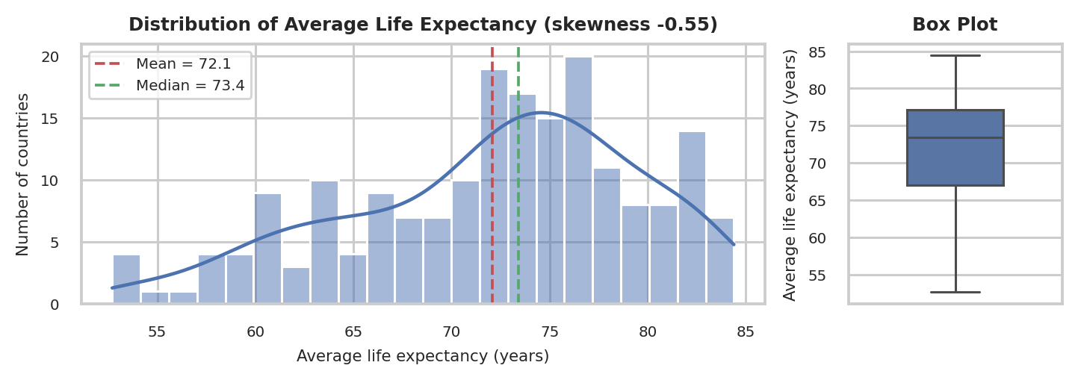
Figure 1. Distribution of average life expectancy with mean, median and box plot
Average life expectancy ranges from 52.7 years (Central African Republic) to 84.4 years (Japan), a spread of 31.7 years. The distribution is moderately left-skewed (skewness −0.55): the mean (72.1) is below the median (73.4), and the long tail on the left is made up of countries with low life expectancy. Half of the countries lie between 67.0 and 77.1 years, and the box plot flags no outliers, so low life expectancy is a broad tail rather than a few extreme cases. Male life expectancy (mean 69.6, skewness −0.41) and female life expectancy (mean 74.5, skewness −0.65) show the same left-skewed shape. The tall bar near 73–74 years is partly the five countries that share the placeholder value of 73.7 (Section 2).
Life expectancy band | Countries | Share
Below 60 | 14 | 7.3%
60 to <70 | 49 | 25.5%
70 to <75 | 53 | 27.6%
75 to <80 | 46 | 24.0%
80 and above | 30 | 15.6%

3.2 Count plot: countries per region
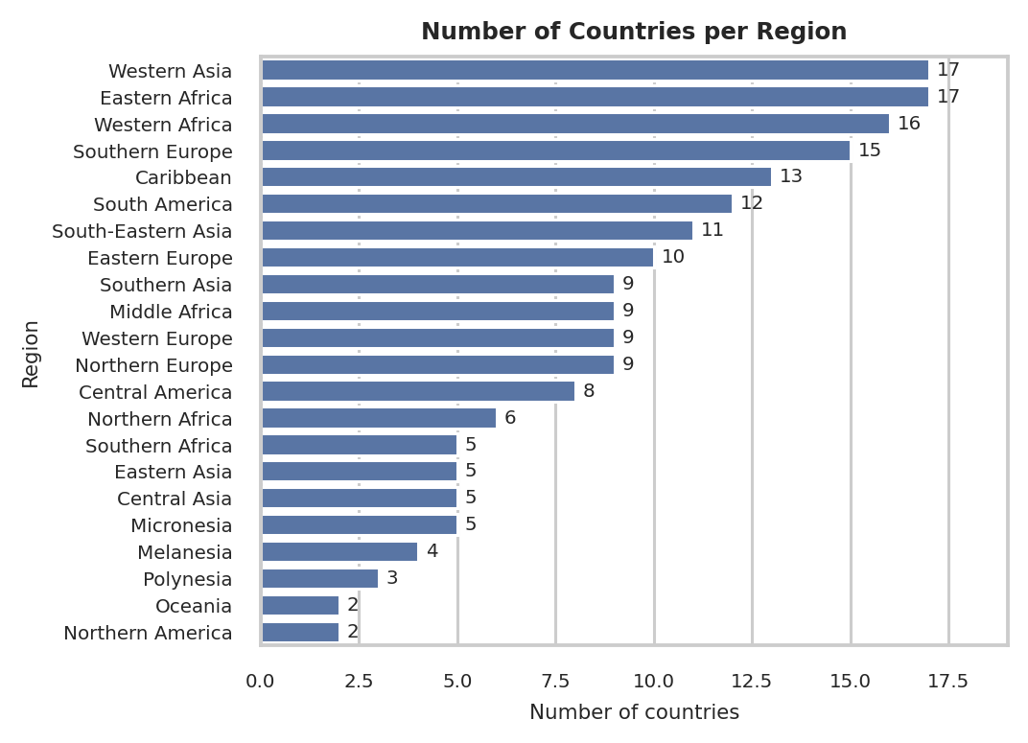
Figure 2. Number of countries in each of the 22 regions
The 192 countries are spread unevenly over 22 regions. Western Asia and Eastern Africa are the largest (17 countries each), followed by Western Africa (16), Southern Europe (15) and the Caribbean (13). Northern America and Oceania have only 2 countries each and Polynesia has 3, so regional averages for these small regions should be read with caution. This matters because region turns out to be a strong grouping variable for life expectancy (Section 4.3).

3.3 Histograms: key socio-economic and health indicators
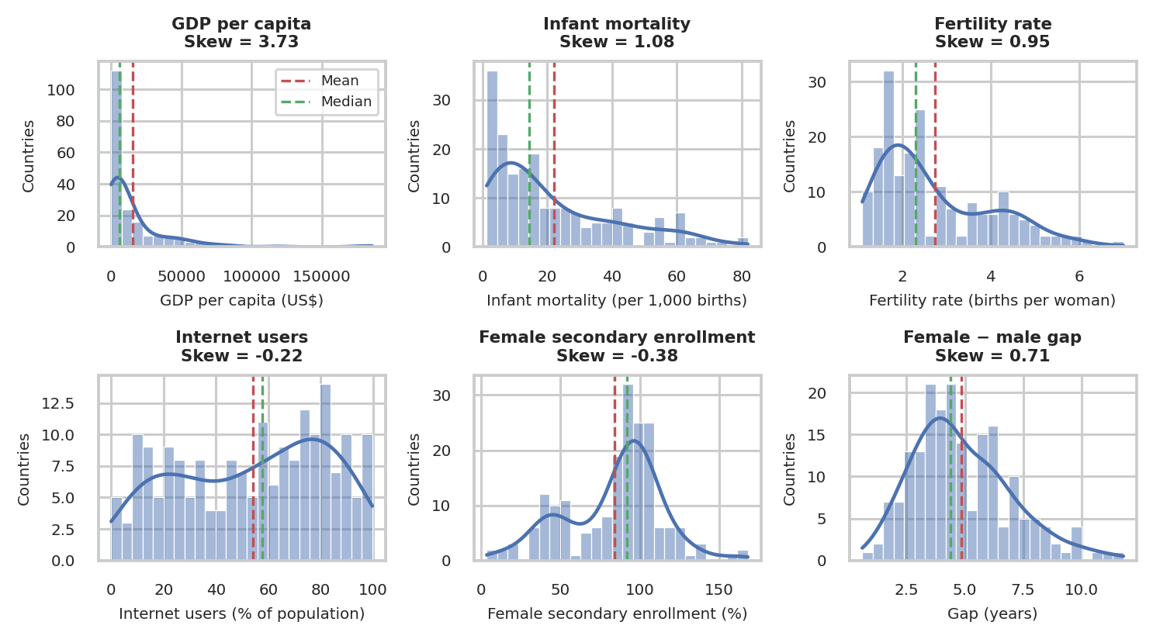
Figure 3. Distribution of six key indicators with mean (red) and median (green)
The six indicators have very different shapes. GDP per capita is extremely right-skewed (3.7): the mean of about US$15,500 is nearly three times the median of about US$5,900, because a few wealthy economies stretch the tail. Infant mortality (1.1) and fertility (0.9) are also right-skewed, with most countries at low values (medians of 14.4 deaths per 1,000 births and 2.3 births per woman) and a smaller group at very high values. Internet use (−0.2) is spread widely across the 0–100% range, and female secondary-school enrollment (−0.4) is left-skewed, with half of the countries at 91.6% or higher. The female–male life expectancy gap (0.7) has a mean of 4.9 years and a median of 4.4 years; women outlive men in all 192 countries, and the gap ranges from 0.6 years (Bhutan) to 11.8 years (Syrian Arab Republic).

4. Bivariate Analysis
Bivariate analysis examines the relationship between two variables to identify patterns, associations, and differences between groups. Both the linear (Pearson) and the rank-based (Spearman) correlation are reported, because the skewed distributions make the Pearson value alone misleading. For GDP per capita, which is strongly skewed, the correlation is also reported on a log scale.

4.1 Heatmap: correlations between numeric variables
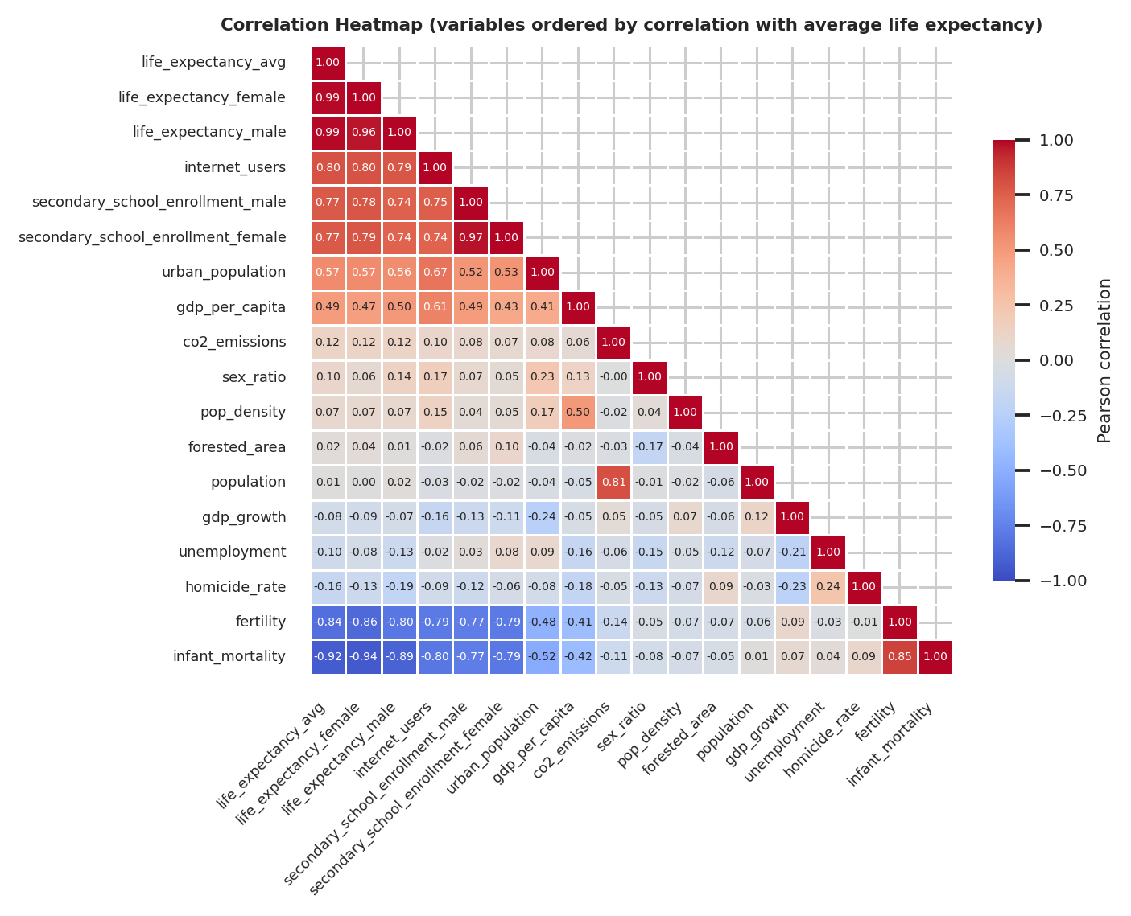
Figure 4. Pearson correlation heatmap of the numeric variables, ordered by correlation with average life expectancy
Life expectancy is closely tied to a cluster of health, education and connectivity indicators. Average life expectancy has its strongest correlations with infant mortality (−0.92), fertility (−0.84), internet users (+0.80) and secondary-school enrollment (+0.77 for both sexes), followed by urban population (+0.57) and GDP per capita (+0.49). Male and female life expectancy move almost together (0.96), as do male and female school enrollment (0.97). Several of these indicators also overlap heavily with each other: female life expectancy and infant mortality (−0.94), infant mortality and fertility (+0.85), infant mortality and internet users (−0.80), and population and CO2 emissions (+0.81). This overlap should be kept in mind before any modelling, because these indicators largely carry the same information.
Several variables show almost no linear relationship with life expectancy: population (+0.01), forested area (+0.02), GDP growth (−0.08), unemployment (−0.10), sex ratio (+0.10), CO2 emissions (+0.12) and homicide rate (−0.16). GDP per capita is the most revealing case. Its Pearson correlation with average life expectancy is only +0.49, yet its Spearman correlation is +0.83 and its Pearson correlation on a log scale is +0.80. Income and longevity are therefore strongly related, but not along a straight line (Section 4.2). The homicide rate also looks stronger on the rank scale (Spearman −0.41) than on the Pearson scale (−0.16).

4.2 Scatter plots: average life expectancy against key indicators
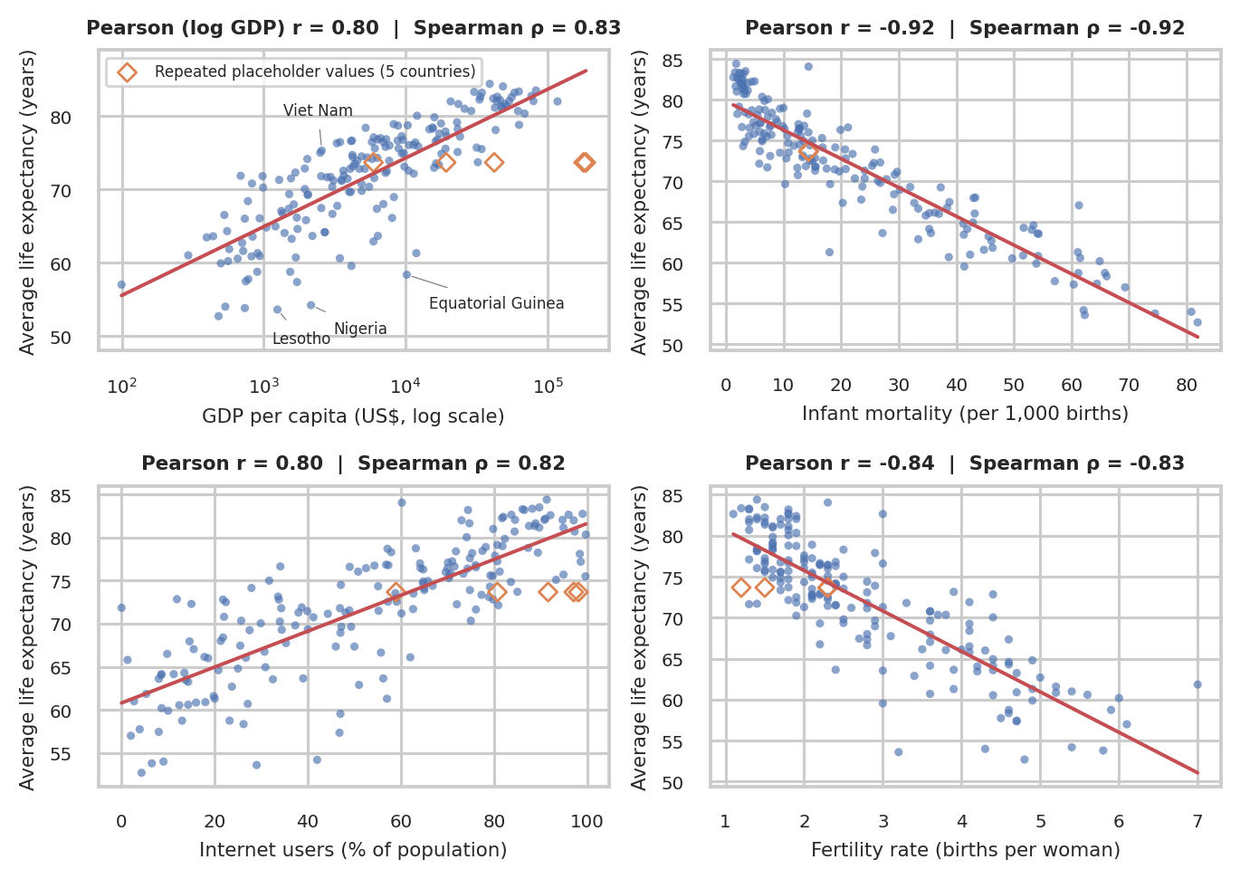
Figure 5. Average life expectancy vs GDP per capita (log scale), infant mortality, internet users and fertility
The scatter plots show the clearest picture of the paradox. Infant mortality (Spearman −0.92) and fertility (−0.83) have steep, close-to-linear relationships with life expectancy, and internet use (+0.82) rises along a broad band. GDP per capita follows a curve rather than a line: it is close to linear on a log scale (r = 0.80, R² = 0.64), which means returns diminish as income grows, with each tenfold increase in GDP per capita going with about 9.4 more years of life expectancy. Income is also a loose guide for any single country. A typical country sits 4.5 years above or below the trend line, and among countries with GDP per capita between US$4,000 and US$12,000, life expectancy runs from 58.4 years (Equatorial Guinea) to 78.9 years (Lebanon), a gap of more than 20 years. Viet Nam (US$2,563, 75.3 years) lives about 17 years longer than Equatorial Guinea (US$10,179, 58.4 years) on a quarter of the income, and four countries with GDP per capita below US$1,000 (the Democratic People’s Republic of Korea, Syrian Arab Republic, Tajikistan and Nepal) have an average life expectancy above 70 years. Nigeria (US$2,154, 54.2 years) and Lesotho fall far below the trend. The orange diamonds mark the five placeholder countries; Monaco and Liechtenstein, at the far right, are not real shortfalls but a result of the repeated value (Section 2).

4.3 Bar plot: average life expectancy by region
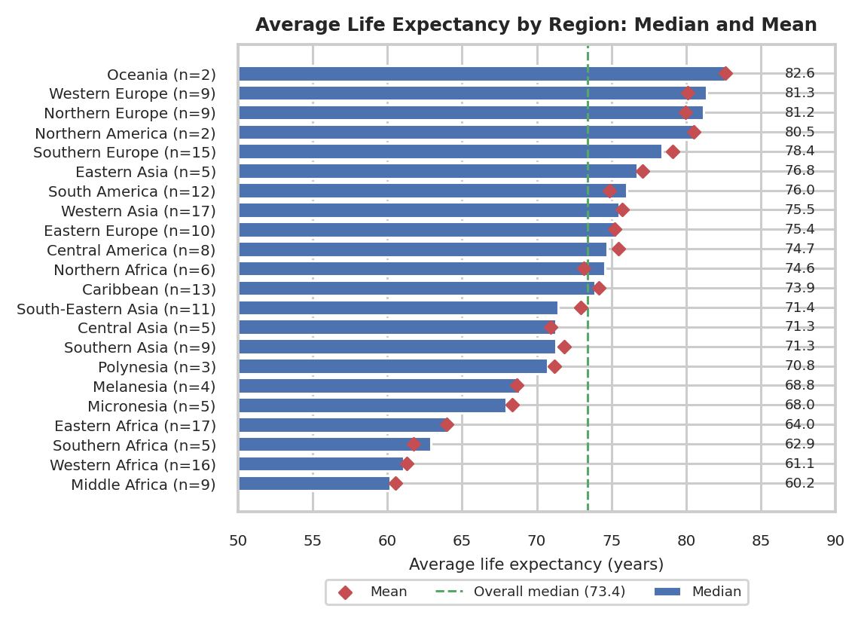
Figure 6. Median (bars) and mean (diamonds) average life expectancy by region
Region explains a large part of the pattern: differences between regions account for about 73% of the total variance in average life expectancy. Four African regions have the lowest medians: Middle Africa (60.2), Western Africa (61.1), Southern Africa (62.9) and Eastern Africa (64.0). Micronesia (68.0) and Melanesia (68.8) follow, and every other region has a median of 70.8 or higher. At the top are Oceania (82.6), Western Europe (81.3), Northern Europe (81.2) and Northern America (80.5), so the gap between Middle Africa and Oceania is about 22 years. Oceania and Northern America have only 2 countries each, so their medians are fragile. The mean differs noticeably from the median in Southern Africa (61.7 vs 62.9), South-Eastern Asia (73.0 vs 71.5) and South America (74.9 vs 76.0), so a few countries pull those regions up or down. The female–male gap also varies by region: it is widest in Eastern Europe (8.1 years on average, led by the Russian Federation at 10.7, Belarus at 10.0 and Ukraine at 9.8) and narrowest in Western Africa (2.7), Southern Asia (3.0) and Melanesia (3.2). It is not largest where life expectancy is lowest: the average gap is 3.6 years in countries below 60 years of life expectancy and 6.1 years in the 70 to <75 band.
Sensitivity check. When the five countries with placeholder life-expectancy values are excluded (187 countries remain), the conclusions hold. The correlations with average life expectancy change by no more than 0.02, except GDP per capita on the Pearson scale (+0.49 to +0.64), because Monaco and Liechtenstein, the two richest countries, were being counted at 73.7 years. The log-GDP fit improves slightly (r from 0.80 to 0.82, with about 10.0 years per tenfold increase in income), the regions with the lowest life expectancy are unchanged, and Southern Europe and Western Europe move up (medians of 78.4 to 81.0 and 81.3 to 82.0). Excluding the 26 countries with the repeated homicide value of 2.5 (166 remain) makes the homicide link slightly stronger rather than weaker (Spearman −0.41 to −0.46). The placeholder values therefore blur the relationships a little but do not create them.

5. Key Findings
- Life expectancy varies widely, and is not a single bell curve. Average life expectancy runs from 52.7 to 84.4 years and is mildly left-skewed (mean 72.1 vs median 73.4). 14 countries are below 60 years while 30 are at 80 years or above.
- Income matters, but not in a straight line. GDP per capita has a Pearson correlation of only 0.49 with life expectancy but a Spearman correlation of 0.83 (0.80 on a log scale). Each tenfold increase in income goes with about 9.4 more years, so the gains diminish at higher incomes.
- Income alone does not decide longevity, which is the paradox. Countries with GDP per capita between US$4,000 and US$12,000 span 58.4 to 78.9 years of life expectancy, Viet Nam outlives Equatorial Guinea by about 17 years on a quarter of the income, and a typical country sits 4.5 years from the income trend.
- Health, education and connectivity track life expectancy more closely than wealth does. Infant mortality (−0.92), fertility (−0.84), internet use (+0.80) and secondary-school enrollment (+0.77) are all more strongly correlated with life expectancy than GDP per capita (+0.49). These indicators overlap heavily with each other, and correlation does not show cause, so their separate effects cannot be read from this analysis.
- Geography is the strongest grouping pattern. Region accounts for about 73% of the variance in life expectancy. Four African regions have medians of 60 to 64 years, while Oceania, Western Europe, Northern Europe and Northern America have medians of 80.5 to 82.6 years.
- Women outlive men everywhere, but by very different margins. The female–male gap averages 4.9 years and ranges from 0.6 (Bhutan) to 11.8 years (Syrian Arab Republic). It is widest in Eastern Europe (8.1 years) and narrowest in Western Africa (2.7 years).
- Data quality needs attention. Five countries carry identical placeholder life-expectancy values, several columns contain repeated median values (infant mortality 14.35 for 7 countries, CO2 31.3 for 57, homicide 2.5 for 26), and Namibia has the wrong ISO code. The conclusions above are unchanged without the five placeholder countries, but these values should be checked against the raw data.

6. Conclusion
Week 4 completed the EDA deep dive on the cleaned dataset in the context of the Global Life Expectancy Paradox. The univariate analysis described the distribution of average life expectancy, the spread of countries across regions and the shape of six key indicators, while the bivariate analysis examined how life expectancy relates to income, health, education, connectivity and region. The results show that life expectancy is closely linked to health and education indicators and to region, and that it rises with income only with diminishing returns, so wealth alone does not explain why some countries live much longer than others at a similar income. These associations are descriptive and do not prove cause. They give a clear foundation for the modelling and dashboard work in the coming weeks, where the overlapping indicators can be considered together. Before modelling begins, the placeholder life-expectancy values should be verified, the repeated median values checked, and the Namibia ISO code corrected.

